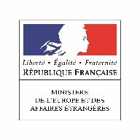 | 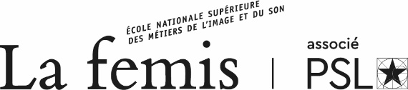

La Fémis Summer Class 2020

May 28 - July 24, 2020

The Summer University is a two-month program for 15 non-European young film directors or film students who wish to develop their practical and theoretical knowledge of documentary filmmaking in France. This program is supported by the French Ministry of Europe and Foreign affairs.

Only applicants from countries where French Institutes provide a scholarship grant for this training can apply (Maghreb, Africa, Latin America, Asia – except South Korea, Japan and Singapore – Eastern Europe – except countries of the European Union – and Middle-East).

Selection
Trainees are selected both by the French Institute of the home country of the applicant and La Fémis, on the basis of the application file, available at the French Institute, and a film directed by the applicant.

Program
The program runs for 8 week of intensive classes, 5 days per week. Each trainee directs a 5 to 10 minutes documentary. Along with its preparation, trainees follow a 4 week theoretical course including many film screenings. The last 4 weeks of the program are dedicated to the documentary filmmaking.

First part (4 weeks)
Classes are given by professionals from the French film industry (who regularly teach at La Fémis, and some of them are Fémis Alumni) in which the following subjects are taught: writing, directing, editing of a documentary and its production conditions (encounters with producers specialized in co-productions and persons in charge of the cinema funds “Aides aux cinémas du monde” and of the “Fabrique du cinéma du Monde”). Technical training workshops take place also during this first part: pocket film workshop (filming with a cellphone), sound and cinematography workshops…
Many screenings illustrate the classes, followed by a Q&A with the director. In 2019, invited directors were: Claire Simon The Graduation), Yolande Zauberman (M), Hendrick Dusollier (Last Days in Shibati), Stan Neumann (A House in Prague), Julien Faraut (In the Realm of Perfection), Mehran Tamadon (Iranian).

Second part (4 weeks): documentary filmmaking
Trainees are involved in the various stages of the project’s development: writing, location scouting, shooting, editing. Each trainee makes a 5 to 10 minutes documentary film. Each, in turn, assumes the different positions in the shooting. Throughout this phase, trainees are supervised by professional tutors who regularly teach at La Fémis.

The ability to speak, write and read in French is compulsory
Applicants must not have over the age of 30 on January 1st, 2020.

This program is reserved for students having a scholarship from the French Institutes.

Application: please contact the French Embassy cultural services or the French Institute, who will hand you the application file.

Calendar

March 13, 2020 | Application deadline
April 6, 2020 | Publication of the list of admitted applicants
May 27, 2020 | Arrival of trainees in Paris
May 28, 2020 | First day of the training (Friday, 9:30 am)
July 24, 2020 | Last day of the training

Contact:

Véronique Cantin, Julie Tingaud

External relations Assistant Deputy Head of International Affairs
Tel + 331 53 41 21 15

